Overview
The Nimbuscare Community Trust has been set up to enable Nimbuscare to invest back into the local communities that it serves.

As one of the largest 'at scale' providers of primary care in the North of England, Nimbuscare provides health care services to more than 250,000 people. It’s a not-for-profit organisation made up of 11 GP practices working collaboratively across York.

Each year, Nimbuscare and its member GP practices will agree a new theme or focus, as well as the amount of funding to be allocated to projects that meet the criteria. The focus for the 2022/2023 financial year is on ‘Connecting in Our Community’

The Nimbuscare Community Trust Fund will support projects and initiatives that have a positive impact on the people living in the York area and some of the East Riding of Yorkshire, as shown on the map below.

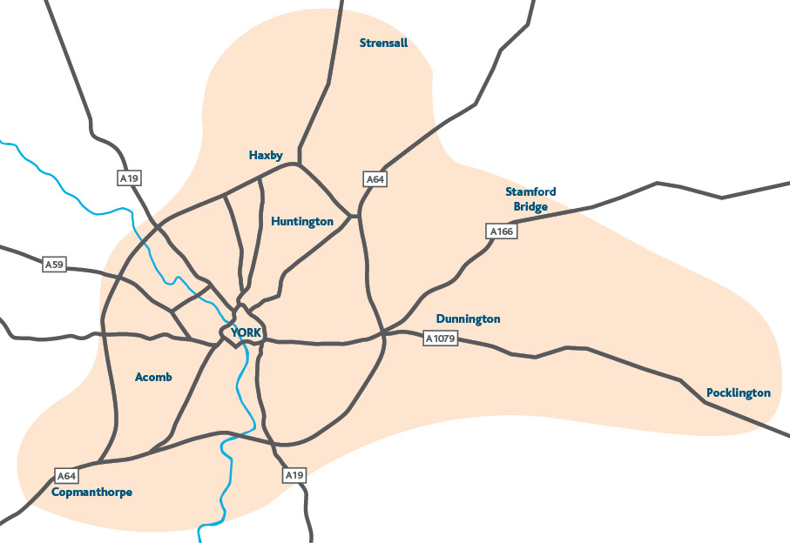

What are the priorities for the fund?
In the 2022/2023 financial year, the fund will support charitable activities that:

- Connects people with the place they live and community life
- Enhance and promote the wellbeing of local people

However, the priorities will be reviewed and agreed annually.

What type of activity can be funded?
Grants will be allocated to projects and activities that help the individuals taking part to feel more connected to the people around them and/or the place where they live, or feel they are playing a useful part in community life. Here are a few ideas and examples:

- Projects that help people to feel useful and a part of communities.
- Projects that bring people together to take part in activities or to volunteer.
- Projects that help people build their self-confidence so they play a more active role in their community.

Grant Availability
Grants of up to £5,000

Applications will open on 13th July 2022 and remain open until 16th September 2022.

A panel will meet during the year to award grants of up to £5,000 to organisations and projects that meet the criteria.

Applications to this fund will be assessed on an ongoing basis subject to available funds. Below is the deadline date that your application needs to be submitted by and the date it will be considered at a panel.

16th September 2022 for a decision November 2022

Eligibility

All groups should meet our general eligibility criteria which can be found here: https://www.tworidingscf.org.uk/how-to-apply/

Groups must:
- Be based in and/or working in York or the area of East riding of Yorkshire as shown on the map above
- Have a management committee with at least 3 unrelated members
- Be a voluntary organisation, community group, registered charity or other not for profit organisation
- Have a bank account in the group’s name (with two unrelated signatories as a minimum)
- Have an annual income of under £500,000 based on current forecast annual income.

Who cannot apply/ what work will not be supported?
- Individuals
- Private Businesses
- National organisations – except where a local branch of a national organisation can demonstrate its autonomy from the national organisation for example where it has its own local management committee and is responsible for its own accounts
- General appeals or sponsorship
- Work normally funded from statutory sources
- Work undertaken by/ on behalf of schools, colleges or universities as part of their statutory curricular activities
- Work undertaken by or on behalf of statutory bodies
- Work for the advancement of religion
- Work where the main beneficiaries are animals
- Work which does not directly benefit people living in the area of benefit.
- Organisations that mainly give funds to other organisations or individuals
- Overseas holidays or trips
Next Steps
An assessor may contact you to obtain further information, please ensure that the person named as the main contact is familiar with the application and can be available to discuss the detail.
All Applications are considered by a local panel and the final decision cannot be changed.
We will aim to get a decision to you within 6 weeks of the programme deadline however we may ‘hold’ your application in a pipeline if we cannot fund it straight away.
We will contact you by email to let you know the outcome.
Payment runs will usually be done on a fortnightly basis. If your application is successful, provided we have everything we need, your payment will be made on the next payment run following your offer email.
If you require any assistance with the completion of your application, please contact Two Ridings Community Foundation on 01904 929500.

