 | Resilience Hub Healthcare Staff Wellbeing  Guidance Notes | 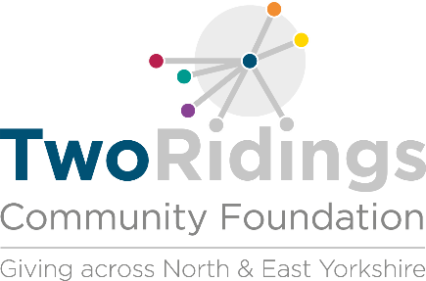

Overview
The Humber and North Yorkshire Resilience Hub was established February 2021, funded by NHS England. The provision of Resilience Hubs has been developed in the wake of the Covid-19 pandemic and is dedicated to supporting the mental health and wellbeing of our health and social care staff, emergency services, and voluntary and community sector organisations and their immediate families. It is part of a network of 40 hubs funded by NHS England across the country.

The hub model developed enables an innovative & unique partnership approach to delivery of support. Collaboration and co-production with key stakeholders have driven design and implementation of the model, with this embedded throughout within the service offer, governance structure and contractual arrangements. The Hub is delivered through a collaboration of partners across the Integrated Care Partnership to meet the needs of all health and care staff. The Hub is a psychologically led model, with an experienced team of psychologists, senior clinicians, assistant psychologists as well as research and operational staff. Hub team members deliver individual clinical assessment and short-long term interventions, as well as providing team support and proactive outreach, both onsite and virtually, to teams and organisations across the Humber and North Yorkshire region.

We are looking to fund genuinely innovative projects designed to engage with health care and emergency services workers who may need support with their mental health and wellbeing. Projects will need to support people to overcome barriers related to accessing health and well-being support to enable them to access Resilience Hub support and/or reduce the likelihood of future escalation of mental health issues and therefore increased risk of requiring high intensity support.

This programme will require a high level of commitment from successful organisations and will include participant and organisational monitoring as well as a focus on evaluation and impact.

Strand 1 – Post- Hub – people referred on for additional help from the Hub into other services
Strand 2 – Pre-Hub – people who are not yet connected to the Hub

Grants

Grants are available of between £5,000 and £25,000 for community groups, small charities and schools working the in ICP (Integrated Care Partnership) area shown below.

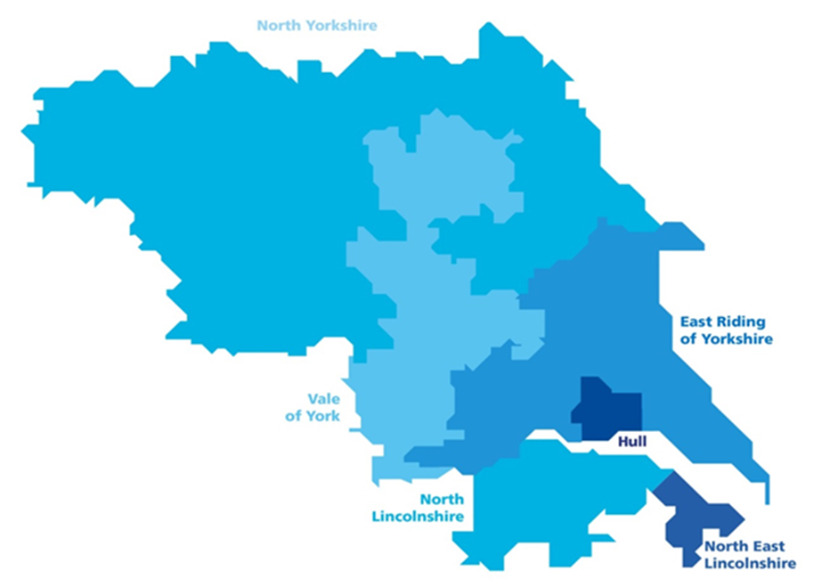

Who should your project be supporting?

The projects will support
- NHS staff and other healthcare staff
- Emergency workers
- VCSE staff who work or volunteer in social/health care
- Care home staff
- Social care staff

Examples of potential projects

1. An existing charitable counselling service starts a new service to engage with health care and emergency services workers
2. An ethnically minoritised community group bring in a qualified counsellor to run sessions for the community of interest to support people who have not only worked in health care but also those who have worked on the front line during the pandemic.
3. An example of outreach

There will be one grant round with decisions on applications for grant awards made in December 2022 by a special panel made up of experts. Deadlines for applications will be:-

31st October 2022

General Eligibility

As a general guide we consider a small charity to have an income of under £500k per annum. If your income is over this we may still be able to fund you. However we recommend that you contact us before making an application.

Applications will be accepted from:-

- constituted voluntary and community groups
- registered charities
- co-operatives
- social enterprises
- community interest companies (CIC’s will be subject to additional scrutiny as outlined in our grant making policy)
- parish councils (provided that the purpose of the grant falls outside of the councils usual remit)
- schools (provided that the purpose of the grant falls outside of the schools usual curricular activities. The income turnover limit does not apply in this case)

Who cannot apply/ what work will not be supported?
- General appeals or sponsorship
- Work which has already started or taken place
- Work undertaken by/ on behalf of schools, colleges or universities as part of their statutory curricular activities

The Process

Applying

- Ensure you are eligible and that the fund is currently accepting applications.
- Complete the online application form. A link to this is found on the https://www.tworidingscf.org.uk/fund/resilience-hub-fund/ page of the Two Ridings Community Foundation website
- Include details of a suitable referee, your referee should be someone who knows your group or organisation and the work you do, but not a management committee member, a relative or someone who will benefit from your services. A suitable person might be a local councillor or a local support organisation such as a Council for Voluntary Service.
- Attach your supporting documents to the online application or send these by post to Two Ridings Community Foundation, Pavilion House, Amy Johnson Way, Clifton Moor, York YO30 4XT or by email to grants@tworidingscf.org.uk

If the supporting documentation is not received within 4 weeks of the date of submission of the online application, or by the advertised closing date where applicable, the application will be withdrawn. Applications will only be processed when all documentation has been received.

Assessment and Award
- All eligible applications will be assessed. An assessor may contact you to obtain further information or to arrange an evaluation. This may be over the telephone or in person.
- All Applications are considered by a special panel and its recommendations are ratified by the Board of Trustees. The final decision cannot be changed and no discussion will be entered into although we will try to provide constructive feedback if we can.
- In certain circumstances applicants will be awarded a pledge. This is the promise of a grant if/ when certain conditions are met.
- Following the panel meeting, we will contact you by email to let you know the outcome.

Monitoring and Completion

- When your project is complete, you must fill in an End of Grant Monitoring Form. This is available as an online form very similar to the online application form and should your application for funding be successful the link to your end of grant report will be sent to you when your grant payment is made. You will not be eligible to apply for further grants from this scheme until we have received this form as it finalises your grant.
- We aim to undertake monitoring visits on a proportion of funded applications and we will contact you to arrange a visit if this is required.
- Successful applicants must ensure that the Foundation is included in any publicity and our logos will be provided for this purpose.

Supporting documents if not attached to the online application form should be sent to:

Two Ridings Community Foundation, Pavilion House, Amy Johnson Way, Clifton Moor, York YO30 4XT or by email to grants@tworidingscf.org.uk

If the supporting documentation is not received within 4 weeks of the date of submission of the online application, or by the advertised closing date where applicable, the application will be withdrawn.

If you require any assistance with the completion of your application please contact Two Ridings Community Foundation on 01904 929500.

