 | DCMS Know Your Neighbourhood Fund –  Guidance Notes | 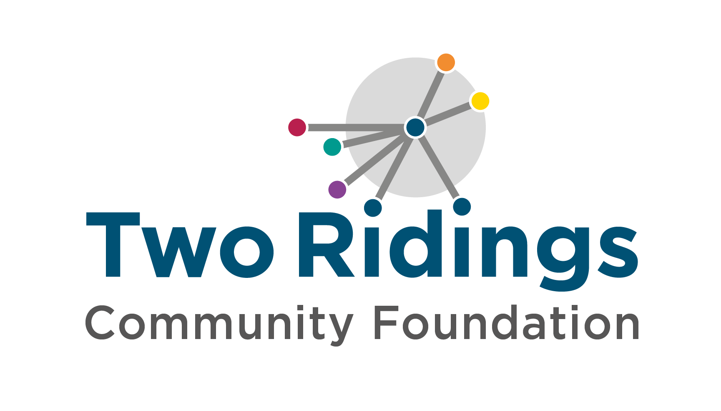

Overview

DCMS Know Your Neighbourhood Fund is a multi-year funding programme in Hull (and nine other areas of the country) that will run until the end of March 2025. The programme is committed to giving people the opportunity to flourish and improve their wellbeing and their pride in place with the overall aims to encourage people to take part in volunteering in Hull and to reduce loneliness and social isolation in the city.
The grant priorities are to:
- Support meaningful and impactful volunteering
- Help people to connect with others in their local area, reducing loneliness.
- Increase volunteer engagement
- Engage people who are not currently participating in activities

The Know Your Neighbourhood Fund is also about learning. This means that the evaluation aspect of the funding is key. So, any group applying for funding must be aware that a key objective of the fund is building the evidence base around ‘identifying scalable and sustainable place-based interventions that work towards widening participation in regular volunteering, and reducing chronic loneliness, as well to exploring impacts on pride in place, wellbeing, skills and confidence.’
So, when you are designing your project, you should consider how you will gather evidence that shows what works, why it works, and who it works for and be mindful of the DCMS objectives.

Priorities

The four key objectives of the programme are:

- To build the evidence to identify scalable and sustainable place-based interventions that work in increasing regular volunteering and reducing chronic loneliness.
- To increase the proportion of people in targeted high-deprivation local authorities who volunteer at least once a month.
- To reduce the proportion of chronically lonely people in targeted high-deprivation local authorities who lack desired level of social connections.
- To enable targeted high-deprivation local authorities, and the local voluntary and community sector in these places, to implement sustainable systems and processes that encourage volunteering and tackling loneliness.

Amount Available

We have three levels of grants groups and consortiums can apply for. We envisage some of the Large Grants and Medium Grants will be eligible to groups only in partnerships and consortiums.
- Large Grants of up to £150,000 – These larger grants we envision partnerships and/or system wide applications (if you are in a large consortium or partnership and require a larger grant please get in touch)
- Medium Grants of up to £50,000 – Single organisation or partnership grants
- Small Grants of £10,000 - £20,000 – Single organisation

Please note that these amounts take into account that you need to allocate some of the funding to the evaluation process. The cost for grantees to contribute to the learning and evaluation should be adequately reflected in the budget.

Eligible Expenditure

- Salaries / part salaries for posts directly relating to the project
- Salaries / part salaries for posts within your organisation providing support/management of the project
- Organisational running costs/overheads
- Event costs such as venue hire, refreshments
- Volunteer expenses
- Training
- Outreach and consultancy work
- Goods and equipment including IT equipment that facilitate the running of the project.

If you have any queries if your expenditure is elligble please get in touch with us – better to check ahead of completing your application.

These are just some examples of expenditure and this list is not exhaustive.

Groups must:
- Be based working to support people in Hull
- Have a management committee with at least 3 unrelated members
- Be a voluntary organisation, community group, small charity or other not for profit organisation
- Have a bank account in the group’s name (with two unrelated signatories)
- National organisations with local branches (with their own management committee and bank account) can apply.

Who cannot apply/ what work will not be supported?
- Individuals
- Private Businesses
- National organisations and their affiliates
- General appeals or sponsorship
- Work normally funded from statutory sources
- Work undertaken by/ on behalf of schools, colleges or universities as part of their statutory curricular activities
- Work undertaken by or on behalf of statutory bodies
- Work for the advancement of religion
- Work where the main beneficiaries are animals
- Work which does not directly benefit people living in the area of benefit
- Overseas holidays or trips

Transparency
There is £1,171,333 to distribute in the second round.

The Process

Applying
- Use the online link to start your application.
- Attach your supporting documents to your application form and submit.
- If supporting documents cannot be attached, then please forward these by email to grants@tworidingscf.org.uk

If you experience any difficulties with completing the application or providing any of the requested documentation, please let us know via email. We recognise there are some more complex questions. Please email us if you need support.

Assessment

The assessment process is very important for Know Your Neighbourhood. All eligible medium and large grants will be assessed by an external assessor who will not only help you bring your application to life but also ensure that you are best placed to deliver the work and that the evaluation element of your project is suitable.

A key aim of KYN is to build the evidence base, capturing information on what works that will support both individual projects to demonstrate their impact whilst adding to our overall understanding. With this in mind, evaluation, and ensuring the opportunities for robust methodologies, will be a key part of grant assessments. The application form includes specific question to enable the panel to assess suitability for robust evaluation, and the guidance below details more information on how evaluation is intended to be implemented and supported across projects.

Award
- All Applications are considered by a local panel and the final decision cannot be changed.
- As this is national programme and a focus on evaluation the process for decision making may take longer. We will keep groups informed and updated.
- We will contact you by email to let you know the outcome. When we contact you we will copy in a trustee/member of your management committee so it is important that we have email addresses for your Board members.
- Payments are likely to be instalments over the duration of the programme.

If you require any assistance with the completion of your application, please contact Two Ridings Community Foundation on 01904 929500.

