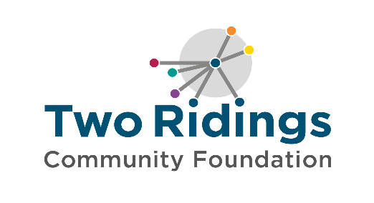

Two Ridings Community Foundation

Equality and Diversity monitoring form

Diversity, Equity and Inclusion are core values at Two Ridings Community Foundation. We are committed to improving the diversity of our workforce and strive to create a workplace that reflects the communities we serve and is representative of all sections of society.

To assist us with monitoring our Diversity, Equity and Inclusion policy we would appreciate your help by completing the questions below. Filling in this form is entirely voluntary and if you do not wish to complete any section please leave it blank.

Please return the completed form with your application.

This form is used for monitoring purposes only. It will be kept separate from your application form and will not be seen or used by the short listing panel in selecting candidates for interview or any stage of the application process.

Gender Male ☐ Female ☐ Intersex ☐ Non-binary ☐ Prefer not to say ☐
If you prefer to use your own term, please specify here:

Are you married or in a civil partnership? Yes ☐ No ☐ Prefer not to say ☐

Age 16-24 ☐ 25-29 ☐ 30-34 ☐ 35-39 ☐ 40-44 ☐ 45-49 ☐ 50-54 ☐ 55-59 ☐ 60-64 ☐ 65+ ☐ Prefer not to say ☐

What is your ethnicity?
Ethnic origin is not about nationality, place of birth or citizenship. It is about the group to which you perceive you belong. Please tick the appropriate box

White
English ☐ Welsh ☐ Scottish ☐ Northern Irish ☐ Irish ☐
British ☐ Gypsy or Irish Traveller ☐ Prefer not to say ☐
Any other white background, please write in:

Mixed/multiple ethnic groups
White & Black Caribbean ☐ White & Black African ☐
White & Asian ☐ Prefer not to say ☐
Any other mixed background, please write in:

Asian/Asian British
Indian ☐ Pakistani ☐ Bangladeshi ☐ Chinese ☐
Prefer not to say☐
Any other Asian background, please write in:

Black/ African/ Caribbean/ Black British
African ☐ Caribbean ☐ Prefer not to say☐
Any other Black/African/Caribbean background, please write in:

Other ethnic group
Arab ☐ Prefer not to say ☐
Any other ethnic group, please write in:

Do you consider yourself to have a disability or health condition?
Yes ☐ No ☐ Prefer not to say ☐

What is the effect or impact of your disability or health condition on your ability to give your best at work? Please write in here:

The information in this form is for monitoring purposes only. If you believe you need a ‘reasonable adjustment’ to help with your application, then please complete our ‘Removing Barriers form’

What is your sexual orientation?
Heterosexual ☐ Gay ☐ Lesbian ☐ Bisexual ☐
Prefer not to say ☐
If you prefer to use your own term, please specify here:

What is your religion or belief?
No religion or belief ☐ Buddhist ☐ Christian ☐ Hindu ☐ Jewish ☐
Muslim ☐ Sikh ☐ Prefer not to say ☐
If other religion or belief, please write in:

Do you have caring responsibilities? If yes, please tick all that apply
None ☐ Primary carer of a child/children (under 18) ☐
Primary carer of disabled child/children ☐
Primary carer of disabled adult (18 and over) ☐
Primary carer of older person ☐
Secondary carer (another person carries out the main caring role) ☐
Prefer not to say ☐
Thank you for completing this form

