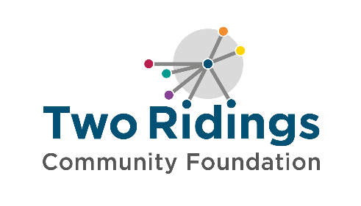
Guidance Notes for Applicants
Two Ridings Community Foundation is committed to improving the diversity of our workforce. We encourage and welcome applications from candidates from all backgrounds, particularly from Black, Asian and Minority Ethnic and Refugee, LGBTQ+ communities and/or disabled people who are currently under-represented within Two Ridings.
Diversity, Equity and Inclusion are core values at Two Ridings Community Foundation. We strive to create a workplace that celebrates diversity, and where everyone feels empowered to bring their full authentic selves to work.

In the Job Description and Person Specification we have outlined the abilities, knowledge and experiences which we believe the successful candidate for this post will be able to demonstrate.

When we are shortlisting we review and score each application anonymously against the person specification. Personal details will not be presented to the short listing panel. To give yourself the best chance of being shortlisted for interview you should aim to:

- Demonstrate in your application form how you meet each of the Person Specification requirements, explaining with illustrations and examples.

- Remember abilities, knowledge and experience can be gained in a variety of settings - for example life experience, paid or unpaid work, work in the home and educational settings.

- Think carefully about your experiences and how these may be transferable to this post.
- Please note that we can only assess you for interview based on information you present on your application form.
- Please do not include your CV. CV’s will not be accepted in place of or in addition to the TRCF Application form and will be removed before shortlisting if submitted.

If you consider yourself to be a disabled person we can help you by offering ‘reasonable adjustments’ for interviews and tests. Please tell us how we can help remove any barriers from our recruitment process by completing the attached ‘Removing barriers form’

Please tell us if you need any of our forms in an alternative format or large print.

We look forward to hearing from you.

