 | Nidderdale Plus Community Fund  Grants Awarded, Round 2024-1  April 2024 | 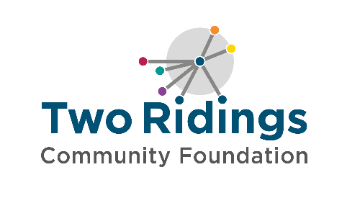

Organisation Name | Project Summary | Amount Awarded
Kirkby Malzeard Mechanics Institute | Renovating unused outside space into a community social space. | £2,000
Nidderdale Fell & Trail | Branded start and finish funnel and flags to support annual 10k run event. | £1,600
Pateley Bridge Dramatic Society | Contribution towards essential safety curtain to enable Playhouse performances. | £2,000
Glasshouses Cricket Club | New cricket nets and returning the scoreboard to use. | £1,531
Darley Cricket Club | Team shirts, kit, equipment and training costs for a new junior cricket team. | £2,000
Highside Playing Field Association | Contribution to site improvements and sports equipment to increase revenue potential. | £2,000
In Harmony Choir | Contribution to ongoing project costs of venue and choir leader fees to keep subscription fees down for choir members. | £1,000
Nidderdale Young Farmers' Club | Contribution to costs to keep club subscription affordable for local young farmers. | £1,343
Dacre Banks Bowling Club | Replacement wooden edging, roller and sprayer to maintain bowling green, serving current and new members. | £2,000
Dacre & Hartwith Playing Fields Association | Renovations (new doors) to the cricket pavilion. | £2,000
Warsill Parish Hall | Funding towards legal costs to set up local village hall as community asset and CIO in rurally isolated North Yorkshire. | £2,000
Pateley Bridge & Upper Nidderdale Bowling Club | Funding for window replacement costs for the club bowling pavilion. | £722
Dacre Tennis Club | Purchase of a powered sweeper to maintain new artificial tennis courts. | £1,126
Dacre and Hartwith Village Hall | A new carpet to enhance the Committee Room area for existing users and hopefully resulting in additional hirers. | £1,875
Warsill Gardening Club | Two trips for a gardening club serving local older people. | £1,515
 | Total Awarded | £24,712

