|  |  |  |
| --- | --- | --- |
| Nidderdale Plus Community Fund logo | **Nidderdale Plus Community Fund Guidance Notes** | **Two Ridings Community Foundation logo** |

## Overview

The Nidderdale Plus Community Fund has been established by Nidderdale Plus, who are donating the income from their charity shop in Pateley Bridge. The fund aims to provide a sustainable source of funding to support local small, grassroots organisations delivering charitable activity in Nidderdale and the surrounding area. The priorities will be updated each year, in line with local need and opportunity.

## Fund priorities

We would particularly like to receive applications from organisations who are:

* promoting wellbeing
* fostering independence
* cultivating a sense of belonging
* community energy needs

We will give priority to applicants that:

* can evidence demand
* are working with people who need extra support to stay independent and well

## Who can apply?

The Nidderdale Plus Community Fund grants are targeted at organisations with a turnover under £200K with charitable aims where a small amount of money can make a significant difference. You can only apply if you are based in or serving people living in Nidderdale and the surrounding area as indicated on the map below.

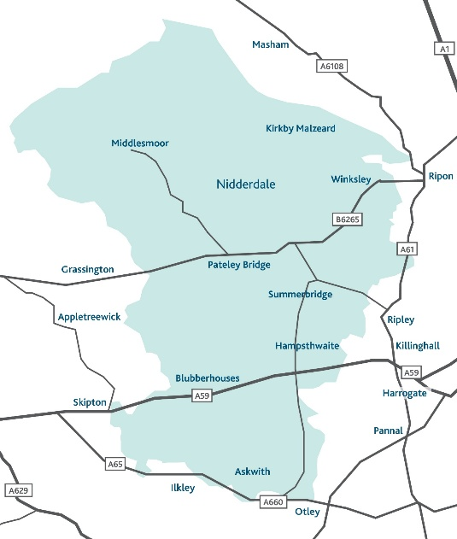

## How much you can apply for

In this round, grants will be available of up to £2,000. It is anticipated that the expenditure would be completed within 18 months of the grant award.

If funding is requested for a specific project, the scheme can fund 100% of project costs or can be part of a combination of funding to meet the full amount needed. However, it is unlikely that priority will be given to projects where the grant award would represent less than 20% of the total project cost.

**Applications deadline - noon on 24th March 2025**

Decisions will be communicated by the end of May 2025

## What grants can be used for

The Nidderdale Plus Community Fund is keen to support community inspired and led projects, activities and events which help to demonstrate how a small investment can make a big difference to the local community. We expect that applications should reflect the concerns and priorities of the target beneficiaries and fit well with existing community services/activities.

Some examples of what these grants can support are below (this list is not exhaustive):

* Running activities and services
* Helping cover essential overheads / running cost such as utilities, rent, insurance and staff not including direct activity / service delivery
* Cover the costs of small capital schemes
* Events that can demonstrate impact beyond the event itself e.g. is there a legacy from the event that will meet the needs of your community, or will the event help you increase long term volunteering.

This fund supports full cost recovery – we would strongly encourage applicants to include a proportion of their overheads on this application. You can learn more about Full Cost Recovery here: <https://www.tworidingscf.org.uk/wp-content/uploads/2019/03/Full-Cost-Recovery.pdf>

Please note that overhead costs must not include any costs associated with commission-based payments for fundraising.

Please note – this fund only accepts full cost recovery and overheads relating to direct delivery. We can also accept applications that are predominantly for overhead costs. Overheads include organisational running costs such as:

* Rental costs
* Heating, lighting, water rates
* Insurance
* Core staff costs (not involved in direct delivery)
* Stationery, small capital items, internet
* Volunteer costs

## Organisational / Group Eligibility

The Nidderdale Plus Community Fund welcomes applications from charitable and voluntary groups with very few exceptions. In order to apply to the **Nidderdale Plus Community** **Fund** your organisation must be:

* Either a small voluntary organisation, community group, small charity or other type of not-for-profit organisation provided that the purpose of the grant is wholly charitable (please see our [FAQs](https://www.tworidingscf.org.uk/frequently-asked-questions/) for additional requirements for CIC’s & CBS’s )
* Be based in and / or delivering activities or services primarily for the benefit of people in Nidderdale and the surrounding area (see map)
* Have a governing document (also known as a constitution, rules, memorandum, or articles of association) in the name of their organisation which outlines their charitable objectives and includes a charitable dissolution clause with a named body in their asset lock
* Have a bank account in your group/ organisation’s name with at least two signatories, who are not related to one another
* Have an annual income of under £200k per annum

## Who and what cannot be funded?

|  |  |
| --- | --- |
| * Private Businesses or individuals * General appeals or sponsorship * National organisations and their affiliates * Work which has already started or taken place / retrospective funding * Work normally funded from statutory sources * Work undertaken by or on behalf of statutory bodies as part of their statutory activities * Prize money * Purchase of gifts * Work of a political nature * Loans, deposits or on-granting * Payment of commission-based fundraisers / fundraising | * Teacher training * Work undertaken by / on behalf of schools, colleges or universities as part of their statutory curricular activities, including teacher training * Work where the main beneficiaries are animals * Work which does not directly benefit people living in the area of benefit * Overseas holidays or trips * Organisations that mainly give funds to other organisations or individuals * Work for the advancement of religion (applications are accepted from religious groups working in the community provided that the main focus of the project is not proselytising) * Work normally undertaken by infrastructure organisations |

## How to apply

1. Ensure you meet all the eligibility and fund criteria above and that the fund is currently accepting applications.
2. Complete the online application form. A link to this is found on the <https://www.tworidingscf.org.uk/fund/nidderdale-plus-community-fund/> page of the Two Ridings website. The online application process is straightforward and provides an option to save your application as you go so you can dip in and out of the application before you submit it. If required a paper version of the application form is available on request.
3. Attach your supporting documents (listed below) to the online application or if you have requested a paper version of the application form, please send your completed application form along with copies of your supporting documents to: Two Ridings Community Foundation, Pavilion 2000, Amy Johnson Way, YO30 4XT

* The organisations constitution/governing document/set of rules
* Contact details (address & email) of your management committee / trustees / directors.
* The organisations most recent annual accounts or financial records that show your organisation’s balance of funds, income and expenditure. If you do not have financial records that cover a full year then you will need to provide a set of management accounts.
* A safeguarding policy if your organisation works directly with children or vulnerable adults.

**Applications will only be processed when all documentation has been received.**

If you do not have all these documents, please do get in touch, we may still be able to consider your application or signpost you to further support.

* If your application is successful, you must provide a copy of a Bank Statement (dated within the last three months) or Paying in slip in the name of the organisation applying. We can not accept transaction lists or screenshots of transaction. [Click here](https://www.tworidingscf.org.uk/wp-content/uploads/2023/10/bank-statement-guidance.pdf) for some guidance on your bank statement.

**NOTE** – **if successful, you must submit your bank statement within 4 weeks of your grant awarded notification** **otherwise your application will be withdrawn**. Please make sure you have access to a statement when you apply.

## Assessment and Award

* All eligible applications will be assessed. One of our volunteer or in-house assessors may contact you to chat about your application to help us better understand your funding request. This may be over the telephone or in person. When assessing applications, we will look at the following:
  + How your group/activity is set up and managed
  + How well your finances are managed
  + Evidence of need for your project
  + Your commitment to ensuring equal opportunities and the inclusivity of your project
  + Value for money offered by the project
  + How well the project meets the fund criteria and the priorities
* All eligible applications will be considered by a funding panel, which may include community members, people with lived experience and / or donors, and Two Ridings Grants committee members. The final decision cannot be changed and no discussion will be entered into although we will try to provide constructive feedback if we can. In certain circumstances applicants will be awarded a pledge. This is the promise of a grant if/when certain conditions are met within a defined timescale.
* There is no appeals process for grant awards. If an applicant feels dissatisfied with the outcome they can make a complaint and our [complaints policy](https://www.tworidingscf.org.uk/key-documents/) provides the detail of how to do this.
* Following the panel meeting, we will contact you by email to let you know the outcome. We aim to give you a decision within 10 weeks of the application deadline.

## Evaluation and Reporting

* + When your project is complete, you must fill in an End of Grant Reporting Form. This is available as an online form very similar to the online application form and should your application for funding be successful the link to your end of grant report will be sent to you when your grant payment is made. After your grant period, you will not be eligible to apply for further grants from this scheme until we have received this form as it finalises your grant.
  + We aim to undertake visits on a proportion of funded applications, and we will contact you to arrange a visit if this is required.
  + Successful applicants are expected to give credit to the support received from The Nidderdale Plus Community Fund and **must** ensure that the fund is acknowledged in any publicity and logos for the fund and any relevant funder will be provided for this purpose with details about how the fund should be described.
  + Successful applicants mustensure that Two Ridings is included in any publicity and our logo’s will be provided for this purpose.

If you require any assistance with the completion of your application please contact Two Ridings on 01904 929500. We are happy to help

## Equality, Diversity and Inclusion

Two Ridings is committed to equality, diversity and inclusion and ensuring an equity of access to all groups and organisations. We expect groups and organisations applying for grants to show that they are aware of equality, diversity and inclusion and can demonstrate commitment to them.