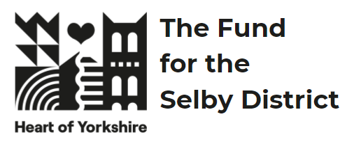 | The Heart of Yorkshire Fund for the Selby District  Guidance Notes | 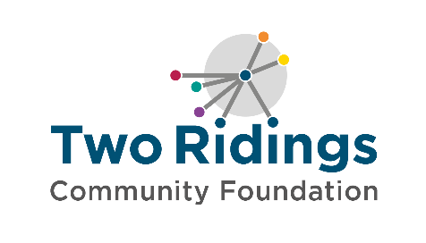

Overview

The Heart of Yorkshire Fund for the Selby District, was established by a £2million donation from Selby District Council, invested as an endowment fund with Two Ridings Community Foundation. The annual interest from this endowment will be awarded in grants to support local people to deliver activities in their community, year on year, forever.

Since the fund was established, Selby District Council has become part of North Yorkshire Council.

This fund provides the local community with a lasting legacy: supporting local charitable activity in the former Selby District in a way that meets the identified needs in the area.

What are the priorities for the fund?

The Heart of Yorkshire Fund for the Selby District supports charitable activity for the wellbeing of people in the Selby areas (please see the map below). Applicants should clearly demonstrate how they are working to address the following priorities which have been identified by Two Ridings from local data and community insights.

We will prioritise projects that address the following:

Health and wellbeing
- support older and vulnerable people to live dignified, productive and healthy lifestyles
- support children and young people to access and enjoy healthy lifestyles (this could be physical activity, access to the outdoors, improving their mental wellbeing)
- improve mental health and wellbeing.
Education and Training
- develop employability skills.
- provide volunteering opportunities.
Environment
- increased biodiversity
- support environmental improvements
Community Sector Resilience
- community spaces providing significant community value requiring funding to stay open.

We are also particularly interested in applications where people with lived experience (experts by experience) of the issues being addressed are involved with the design of the project and/or the running of the organisation / delivering the project.

What type of activity can be funded?

The list below is not exhaustive but gives an idea of the types of project that the fund may support:

- Befriending schemes
- Activities to bring people together
- Information, advice and guidance
- Sporting activity
- Transition work for children going from primary school to secondary school
- Counselling
- Peer support groups
- Volunteer training
- In Bloom groups

Grant Availability

Grants between £2,000 and £10,000 can be applied for between 22 April 2024 and 12pm, 17 June 2024.

The fund will support direct project costs. The fund is committed to the principle of full cost recovery to ensure that groups are supported with ongoing sustainability. For further information about full cost recovery please see our guide.

Small capital items may be included as part of a bid but should not make up more than 20% of what you are applying for.

The fund may support larger capital costs for community venues with a maximum award of 50% of the total project costs (i.e if your repairs equal £10,000 you can apply for up to £5,000 maximum). These will be prioritised based on supporting the applying venues to stay open.

Eligibility

All groups should meet our general eligibility criteria which can be found here: https://www.tworidingscf.org.uk/how-to-apply

Groups must:
- Be based in and/or working in the Selby area shown below
- Be ‘not for profit’. Please note, we have additional requirements when considering a request from a CIC or Community Benefit Society (CBS).
  - CIC additional requirements
  - CBS additional requirements
- Have a governing document (also known as a constitution, rules, memorandum, or articles of association) outlining charitable objectives and with a charitable dissolution clause.
- Have a bank account in your group/ organisation’s name with at least two signatories, who are not related to one another.
- Have at least three unrelated trustees, directors or management committee members.
- Have an annual income of under £500,000 based on current forecast annual income.

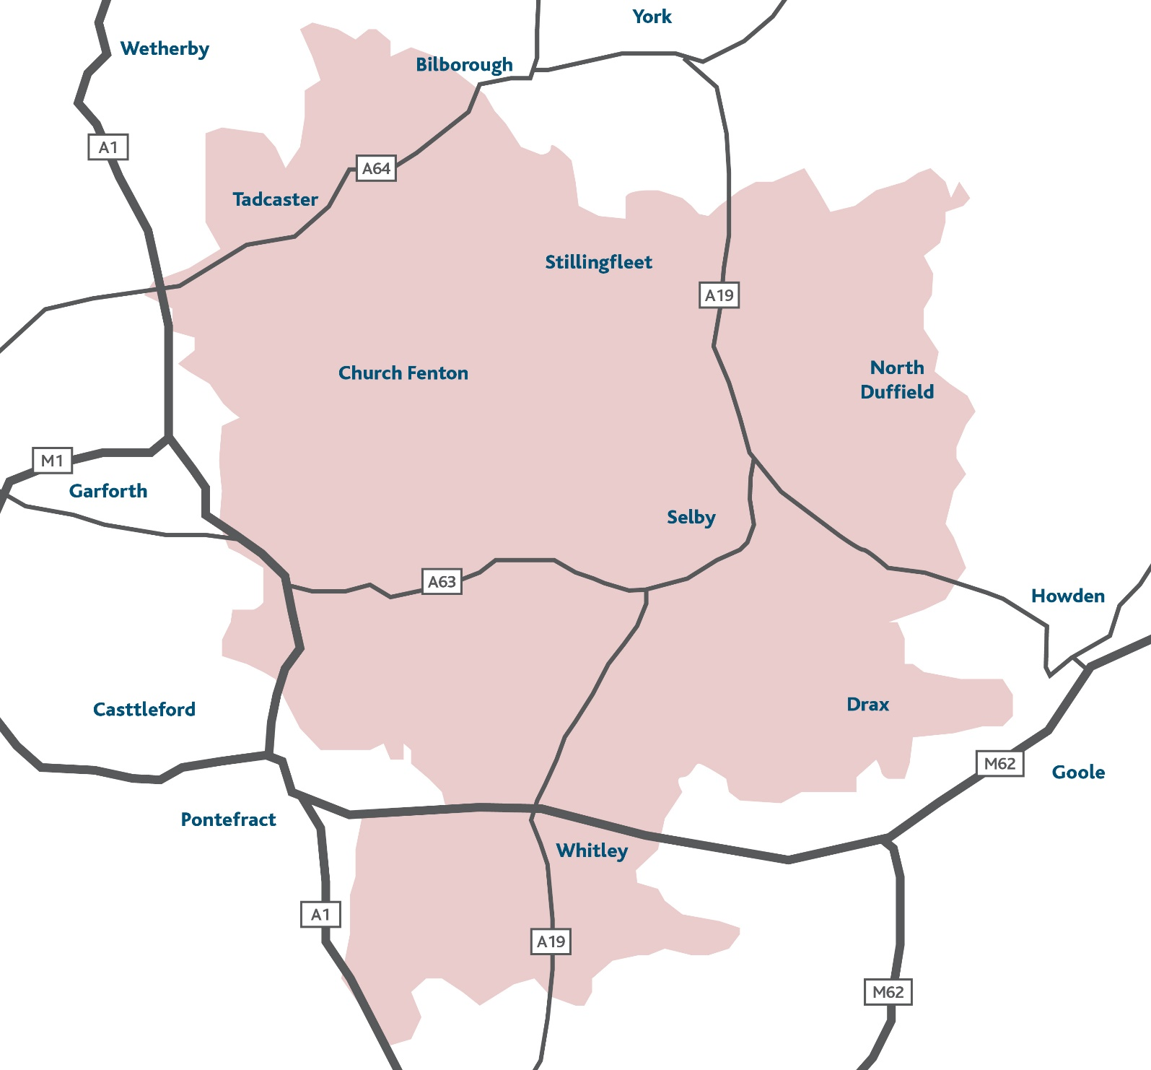

What cannot be funded?

- Private Businesses
- General appeals or sponsorship
- National organisations and their affiliates
- Work which has already started or taken place; we cannot provide retrospective funding.
- Work normally funded from statutory sources
- Work undertaken by or on behalf of statutory bodies as part of their statutory activities
- Prize money
- Purchase of gifts
- Work of a political nature
- Work undertaken by/ on behalf of schools, colleges or universities as part of their statutory curricular activities
- Work for the advancement of religion (applications can be accepted from religious groups working in the community provided that the main focus of the project is not proselytising)
- Work where the main beneficiaries are animals
- Work which does not directly benefit people living in the area of benefit
- Overseas holidays or trips
- Organisations that mainly give funds to other organisations or individuals
- Awards to individuals
- Loans or on-granting

The Process

Applying
- Ensure you are eligible and that the fund is currently accepting applications.
- Complete the online application form. A link to this is found on Two Ridings Community Foundation website at https://www.tworidingscf.org.uk/fund/heart-of-yorkshire-fund

The online application process is straightforward, as it provides applicants with the ability to dip in and out of their application saving changes as they go. Support is also available from the Foundation to assist applicants applying in this way. If required, a paper version of the application form is available on request from the Foundation.

You will need the following supporting information:

- A constitution/governing document/set of rules that sets out the purpose of your organisation and how it is managed.
- Contact details of your management committee / board of trustees / board of directors.
- A copy of your most recent annual accounts or financial records that show your organisation’s balance of funds, income and expenditure. If you do not have financial records that cover a full year, then you will need to provide the records you currently have.
- A copy of a Bank Statement (dated within the last three months) or Paying in slip in the name of the organisation applying.
- A safeguarding policy if your organisation works directly with children or vulnerable adults.

If you do not have all these documents, please do get in touch, we may still be able to consider your application or signpost you to further support.

- Attach your supporting documents to the online application or send these by email to grants@tworidingscf.org.uk
- If you have requested a paper version of the application form, please send the complete form and supporting documents to: Two Ridings Community Foundation, Pavilion 2000, Amy Johnson Way, YO30 4XT.

Applications will only be processed when all documentation has been received.

Assessment and Award
- All eligible applications will be assessed. A volunteer or staff member assessor may contact you to obtain further information or to arrange an evaluation. This may be over the telephone or in person. When assessing applications, we will look at the following:
  - How your group/activity is set up and managed
  - Your finances
  - Evidence of need for your project
  - Your commitment to ensuring equal opportunities and the inclusivity of your project
  - Value for money offered by the project
  - How well the project meets the fund criteria and the priorities.
- All applications are considered by an advisory panel for The Heart of Yorkshire Fund and recommendations are ratified by the Two Ridings Community Foundation Grants Committee. The final decision cannot be changed, and no discussion will be entered into although we will try to provide constructive feedback if we can. In certain circumstances applicants will be awarded a pledge. This is the promise of a grant if/when certain conditions are met.
- There is no appeals process for grant awards. If an applicant feels dissatisfied with the outcome they can make a complaint and our complaints policy provides the detail of how to do this.
- Following the panel meeting, we will contact you by email to let you know the outcome.
Monitoring and Evaluation

- When your project is complete, you must fill in an End of Grant Monitoring Form. This is available as an online form very similar to the online application form. Should your application for funding be successful, the link to your end of grant report will be sent to you when your grant payment is made. You will not be eligible to apply for further grants from this scheme until we have received this form as it finalises your grant.
- We aim to undertake monitoring visits on a proportion of funded applications, and we will contact you to arrange a visit if this is required.
- Successful applicants are expected to give credit to the support received from The Heart of Yorkshire Fund and must ensure that the fund is acknowledged in any publicity and logos for the fund and any relevant funder will be provided for this purpose with details about how the fund should be described.

If you require any assistance with the completion of your application, please contact our Grants Team on 01904 929500. We are happy to help.

