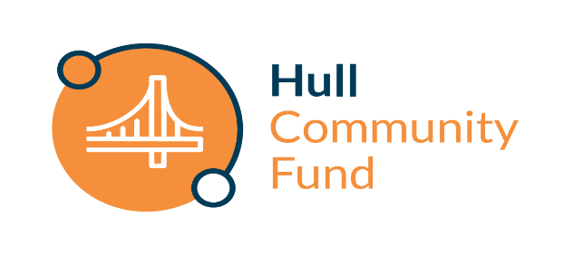 | Guidance Note | 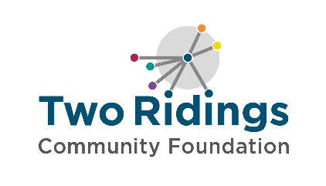

Overview
The Hull Community Fund has been set up as a partnership between Hull City Council, Hull CVS, HEY Smile Foundation, Forum CIO and Two Ridings Community Foundation. The fund focuses on building on and strengthening the dynamism, impact and potential of Hull’s voluntary and community groups and their vital contributions to life in the city. Grants will support vibrant and purposeful community action to improve the wellbeing of people in the city, especially for those who experience greatest disadvantage.

Fund priorities
Organisations should be working towards at least one of the following priorities which are based on the shared ambitions of Hull City Council’s community plan for the city’s development. Applicants should clearly demonstrate how they are working to address at least one of the following priorities:

Health and wellbeing
- support older and vulnerable people to live dignified, productive and healthy lifestyles
- support children and young people to access and enjoy healthy lifestyles (this could be physical activity, access to the outdoors, improving their mental wellbeing)
- improve mental health and wellbeing.
- Targeted support for inclusion health groups who face barriers in accessing health and care services.
Education and Training
- develop employability skills.
- provide volunteering opportunities.
Culture and Heritage
- increase accessibility of culture and heritage opportunities
- Community arts initiatives, particularly for traditionally excluded communities
Environment
- increase biodiversity
- support environmental improvements

Your application could be for direct delivery of the above or to support organisations working on the above themes to become more stable and resilient.

We are also particularly interested in applications where people with lived experience (experts by experience) of the issues being addressed are involved with the design of the project and/or the running of the organisation / delivering the project.

Who can apply?
Hull Community Fund grants are targeted at small organisations (under £150,000 turnover) with charitable aims where a small amount of money can make a significant difference. You can apply if you are based in or serving the people of Hull – please see map below:

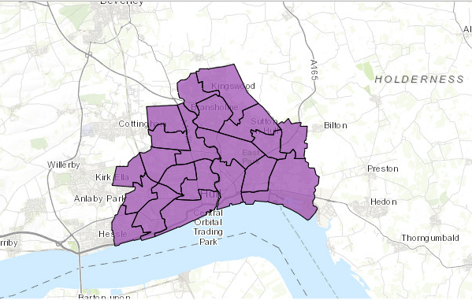

How much you can apply for
We have a total funding pot of £50,000 for this first year. This will be distributed as:

- x3 Step Change grants – up to £10,000 each
These grants are for groups to make a necessary ‘step change’ needed to increase their capacity or support them towards sustainability, and as part of that, to contribute towards running costs.

- x10-20 Activity grants – up to £2,000 each

The deadline for applications is noon on the 2nd September 2024.

What grants can be used for
You can apply for either an activity grant (up to £2,000) to help address a gap in provision or a Step-Change grant (up to £10,000). Please note you will only be able to apply for one Step-Change grant from the Hull Community Fund.

As part of your application, the Hull Community Fund can also support a contribution towards core overhead costs (rent/ heating/ lighting etc).

Applying for a Step-Change grant?
You must also be able to demonstrate a ‘Step Change’. This means that this grant will support your organisation to become more stable and resilient. You should be able to demonstrate how your organisation would be better off after receiving funding. For example, maybe you need your rental costs covering for six months whilst you work on establishing new income to cover future rent. Perhaps you would like to train your staff or volunteers so that they are better equipped. Or you recognise the need for increasing your administration hours to review policies and procedures.

Some examples of what a Step-Change grant can support are below (this list is not exhaustive):
- Trialling the employment of your first member of paid staff
- Staff training
- Trustee training
- Volunteer training and management
- Fundraising (we cannot support payment of commission-based fundraisers)
- Business planning and development
- Developing monitoring and learning
- Marketing and communications
- Purchasing software to support your organisation
- Small capital costs (small capital items can form part of the budget but should not make up more than 20% of the amount applied for)

Applying for an Activity grant?
You can apply for direct activity / project costs and pilot projects. Grants can fund 100% of the activity costs or can be part of a combination of funding to meet the full amount needed, however it is unlikely that priority will be given to projects where the grant award would represent less than 20% of the total project cost. If you are applying for a percentage of the total costs, please tell us what other funding has been secured or how you will secure the remaining funds.

Some examples of what an Activity grant can support are below (this list is not exhaustive):
- Activity costs for young people in an area of disadvantage
- Volunteer recruitment and training
- Pilot projects for an activity
- Befriending schemes
- Counselling and peer support groups
- Purchase of equipment to extend activities to increase participation
- Events that can demonstrate impact beyond the event itself e.g. is there a legacy from the event that will meet the needs of your community, or will the event help you increase long term volunteering.

General Eligibility
In order to apply to the Hull Community Fund your organisation must be:
- Either a small voluntary organisation, community group, small charity or other type of not-for-profit organisation provided that the purpose of the grant is wholly charitable (please see our FAQs for additional requirements for CIC’s & CBS’s )
- Be based in Hull and / or delivering activities or services in Hull
- Have a governing document (also known as a constitution, rules, memorandum, or articles of association) in the name of their organisation outlining charitable objectives and with a charitable dissolution clause
- Have a bank account in your group/ organisation’s name with at least two signatories, who are not related to one another
- Have an annual income of under £150k per annum

Who and what cannot be funded?
- Private Businesses or individuals  - General appeals or sponsorship  - National organisations and their affiliates  - Work which has already started or taken place / retrospective funding  - Work normally funded from statutory sources  - Work undertaken by or on behalf of statutory bodies as part of their statutory activities  - Prize money  - Purchase of gifts  - Work of a political nature  - Lones, deposits or on-granting | - Work undertaken by/ on behalf of schools, colleges or universities as part of their statutory curricular activities  - Work where the main beneficiaries are animals  - Work which does not directly benefit people living in the area of benefit  - Overseas holidays or trips  - Organisations that mainly give funds to other organisations or individuals  - Work for the advancement of religion (applications are accepted from religious groups working in the community provided that the main focus of the project is not proselytising)  - Work normally undertaken by infrastructure organisations

How to apply
- Ensure you meet all the eligibility and fund criteria above and that the fund is currently accepting applications.

- Complete the online application form. A link to this is found on the Hull Community Fund page of the Two Ridings website. The online application process is straightforward and provides an option to save your application as you go so you can dip in and out of the application before you submit it. If required a paper version of the application form is available on request.

- Attach your supporting documents (listed below) to the online application or if you have requested a paper version of the application form, please send the complete form along with copies of your supporting documents to: Two Ridings Community Foundation, Pavilion 2000, Amy Johnson Way, YO30 4XT

- The organisations constitution/governing document/set of rules
- Contact details (address, email & phone number) of your management committee / trustees / directors.
- The organisations most recent annual accounts or financial records that show your organisation’s balance of funds, income and expenditure. If you do not have financial records that cover a full year then you will need to provide a set of management accounts.
- A safeguarding policy if your organisation works directly with children or vulnerable adults.

Applications will only be processed when all documentation has been received.

If you do not have all these documents, please do get in touch, we may still be able to consider your application or signpost you to further support.

- If your application is successful, you must provide a copy of a Bank Statement (dated within the last three months) or Paying in slip in the name of the organisation applying. We can not accept transaction lists or screenshots of transaction. Click here for some guidance on your bank statement.

Assessment and Award
- All eligible applications will be assessed. One of our volunteer or in-house assessors may contact you to chat about your application to help us better understand your funding request. This may be over the telephone or in person. When assessing applications, we will look at the following:
  - How your group/activity is set up and managed
  - How well your finances are managed
  - Evidence of need for your project
  - Your commitment to ensuring equal opportunities and the inclusivity of your project
  - Value for money offered by the project
  - How well the project meets the fund criteria and the priorities.
- All eligible applications will be considered by a funding panel, which may include community members, people with lived experience and / or donors, and Two Ridings Grants committee members. The final decision cannot be changed and no discussion will be entered into although we will try to provide constructive feedback if we can. In certain circumstances applicants will be awarded a pledge. This is the promise of a grant if/when certain conditions are met.
- There is no appeals process for grant awards. If an applicant feels dissatisfied with the outcome they can make a complaint and our complaints policy provides the detail of how to do this.
- Following the panel meeting, we will contact you by email to let you know the outcome. We aim to give you a decision within 8 weeks of the application deadline.

Monitoring and Evaluation
  - When your project is complete, you must fill in an End of Grant Monitoring Form. This is available as an online form very similar to the online application form and should your application for funding be successful the link to your end of grant report will be sent to you when your grant payment is made. After your grant period, you will not be eligible to apply for further grants from this scheme until we have received this form as it finalises your grant.
  - We aim to undertake monitoring visits on a proportion of funded applications and we will contact you to arrange a visit if this is required.
  - Successful applicants must ensure that Two Ridings is included in any publicity and our logo’s will be provided for this purpose.

If you require any assistance with the completion of your application please contact Two Ridings on 01904 929500. We are happy to help

Equality, Diversity and Inclusion
Two Ridings is committed to equality, diversity and inclusion and ensuring an equity of access to all groups and organisations. We expect groups and organisations applying for grants to show that they are aware of equality, diversity and inclusion and can demonstrate commitment to them.

